Sum Multiples
Platform: LeetCode
Language: C
Module 3, Question 5

Problem Link
https://leetcode.com/problems/sum-multiples/description/

Problem Statement
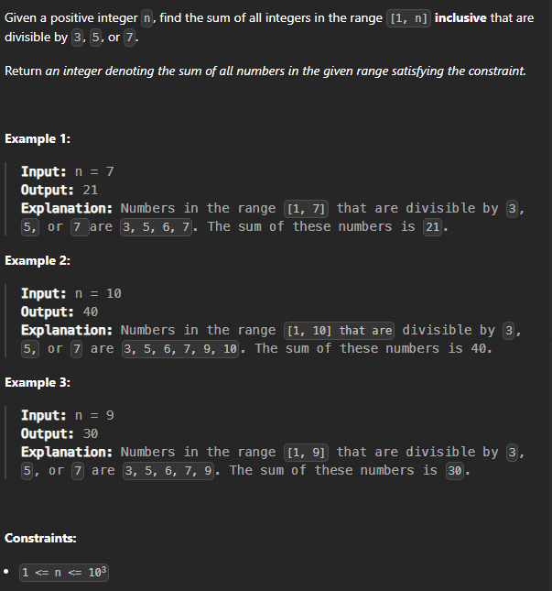

C Code
int sumOfMultiples(int n) {
int sum = 0;
for (int i = 1; i <= n; i++) {
if (i % 3 == 0 || i % 5 == 0 || i % 7 == 0)
sum += i;
}
return sum;
}

Screenshot of Successful Submission



